### Visvesvaraya Technological University



### Belagavi - 590 018, KARNATAKA.

### 

### ASSIGNMENT

### FOR

### Data Structures and Applications (18CS32)

### Submitted by

### NAME: SYED FARHAN USN:4BD20CS104

### PROGRAM CO-ORDINATOR:

### Prof. Naveen H M B.E, M. Tech.,

### Asst. Professor,

### Department of CS&E

### B.I.E.T., Davanagere

### 

### 2021-22

### Department of Computer Science and Engineering.

### Bapuji Institute of Engineering & Technology

### Davangere- 577004



1. There is a series, S, where the next term is the sum of pervious three terms. Given the first three terms of the series, a, b, and c respectively, you have to output the nth term of the series using recursion.

Recursive method for calculating nth term is given below.

**S(n)={ a n=1**

**b n=2**

**c n=3**

**S(n-1)+S (n-2)+S(n-3) otherwise**

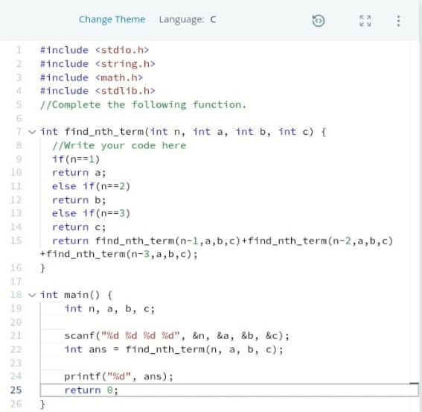

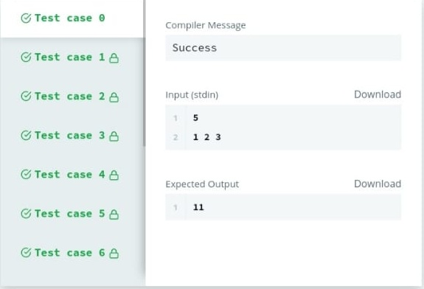

1. You are given an array of integers marks denoting the marks scored by students in a class.

The alternating elements marks0,marks2,marks4  and so on denote the marks of boys.

Similarly marks1,marks3,marks5 and so on denote the marks of girls.

The array name marks works as a pointer which stores the base address of that array. In other words marks contains the address where marks0 is stored in the memory.

For example, let marks=[3,2,5] and marks stores **0x7fff9575c05f**. Then, **0x7fff9575c05f** is the memory address of marks0.

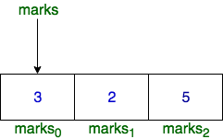

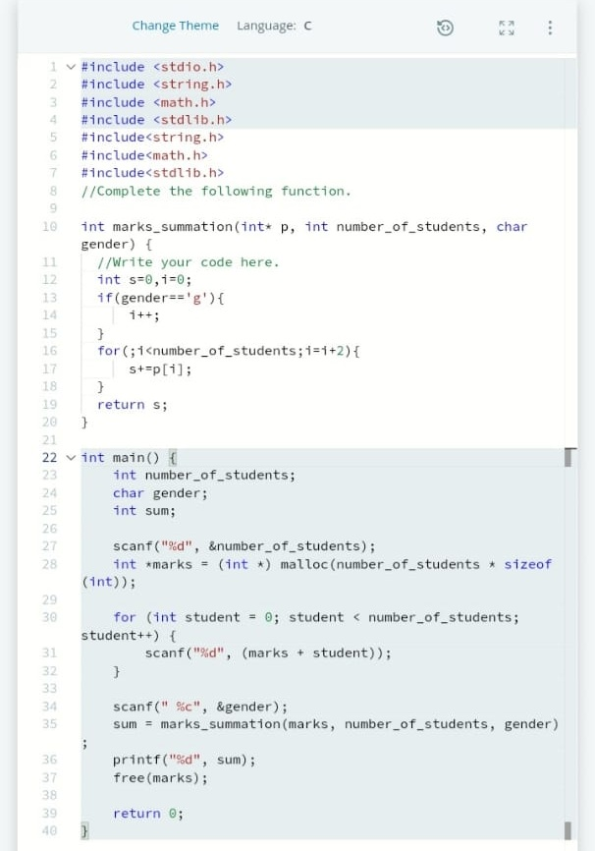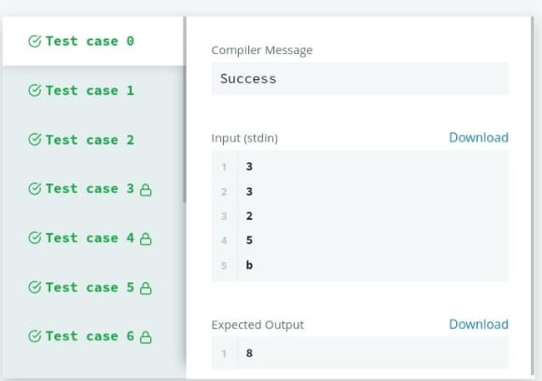

1. Once you have taken the sentence as input, we need to iterate through the input, and keep printing each character one after the other unless you encounter a space. When a space is encountered, you know that a token is complete and space indicates the start of the next token after this. So, whenever there is a space, you need to move to a new line, so that you can start printing the next token.

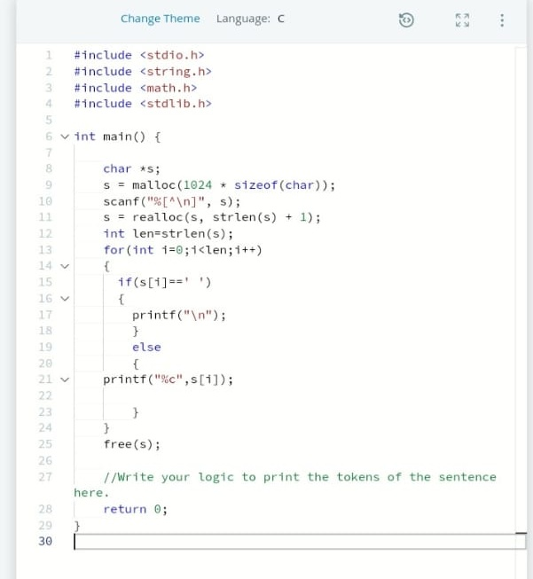

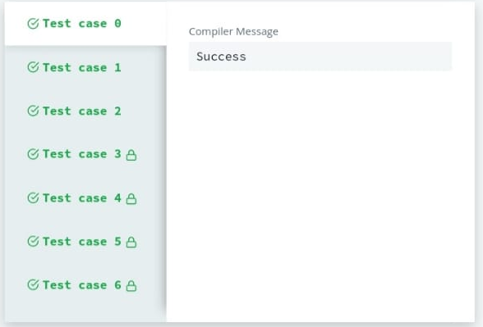

1. Given an array, of size n reverse it. Example: If array arr=[1,2,3,4,5], after reversing it, the array should be arr=[5,4,3,2,1]

.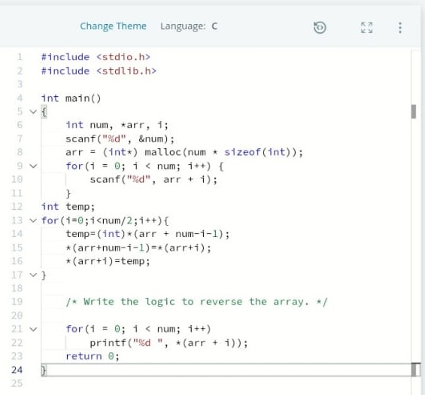

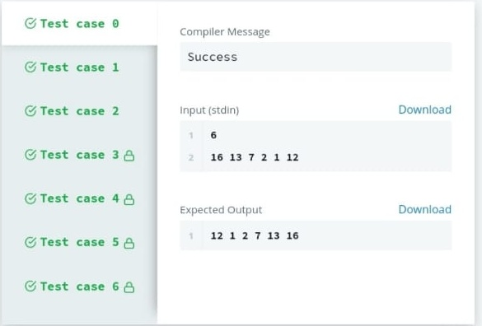

1. In this challenge, create an array of size n dynamically, and read the values from stdin. Iterate the array calculating the sum of all elements. Print the sum and free the memory where the array is stored.

While it is true that you can sum the elements as they are read, without first storing them to an array, but you will not get the experience working with an array. Efficiency will be required later.

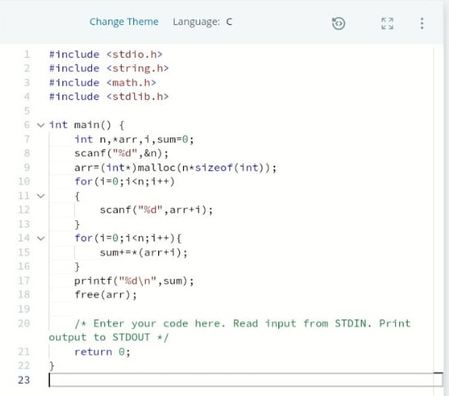

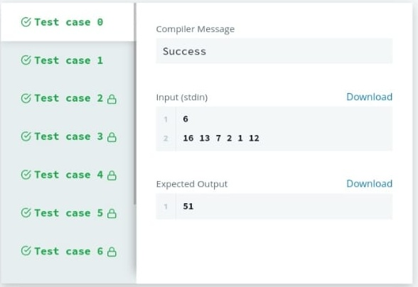

1. Print pattern of numbers from 1 to n as shown below. Each of the numbers is separated by a single space.

4 4 4 4 4 4 4

4 3 3 3 3 3 4

4 3 2 2 2 3 4

4 3 2 1 2 3 4

4 4 2 3 2 4 4

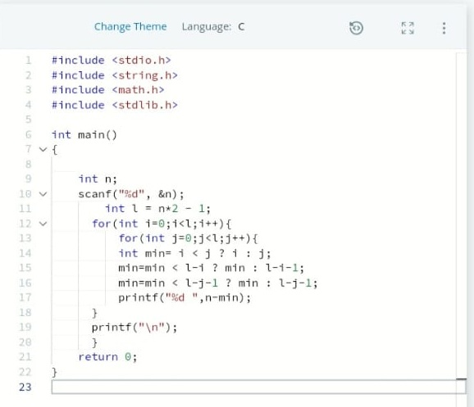

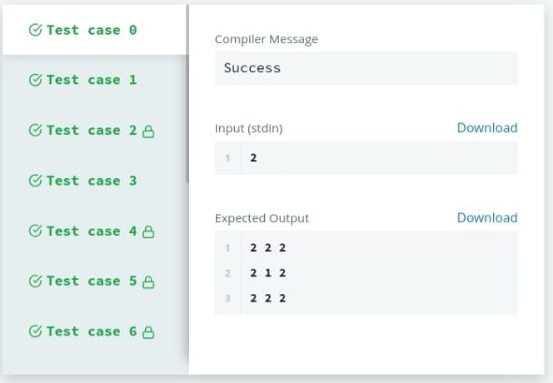

1. The modulo operator, **%**, returns the remainder of a division. For example, **4 % 3 = 1** and **12 % 10 = 2**. The ordinary division operator, **/**, returns a truncated integer value when performed on integers. For example, **5 / 3 = 1**. To get the last digit of a number in base 10, use10 as the modulo divisor. Given a five digit integer, print the sum of its digits.

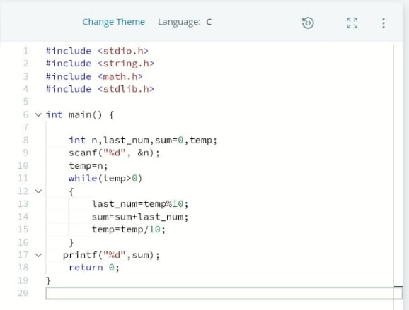

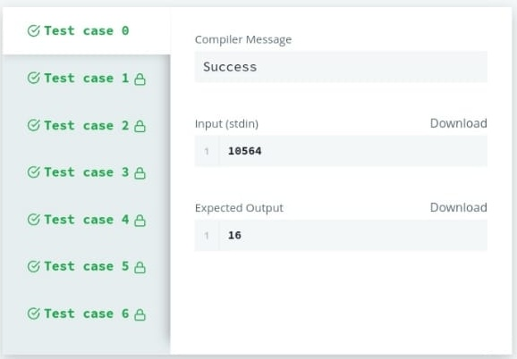

1. For each integer n in the interval [a,b] (given as input) :

* If 1<=n<=9 , then print the English representation of it in lowercase. That is "one" for 1, "two" for 2 , and so on.
* Else if n>9  and it is an even number, then print "even".
* Else if n>9  and it is an odd number, then print "odd".

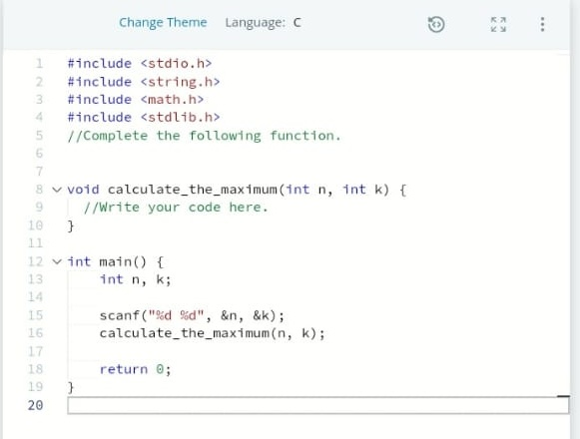

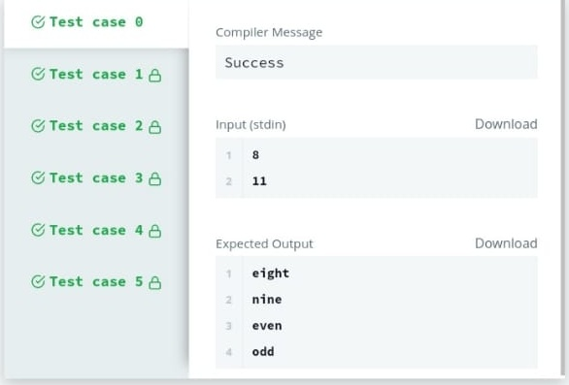

1. Complete the function **void update(int *a,int *b)**. It receives two integer pointers, int* a and int* b. Set the value of a to their sum, and  to their absolute difference. There is no return value, and no return statement is needed.

* a’=a+b
* b’=|a-b|

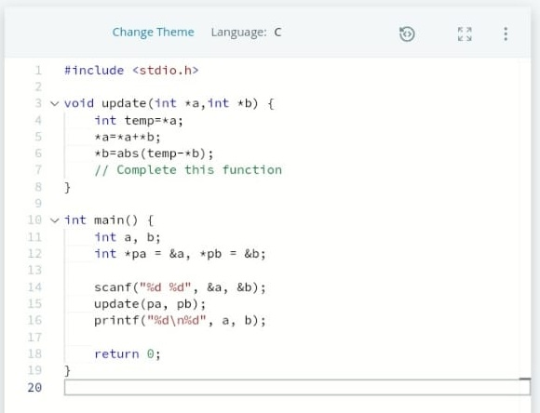

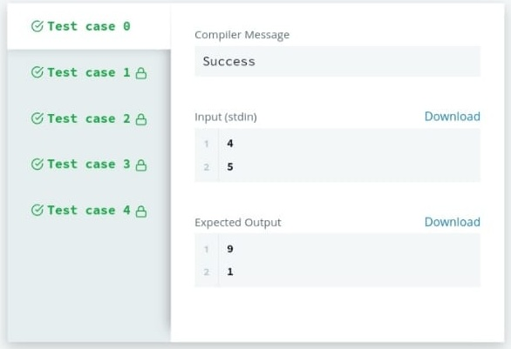

1. Write a function **int max_of_four(int a, int b, int c, int d)** which reads four arguments and returns the greatest of them. There is not built in max function in C. Code that will be reused is often put in a separate function, e.g. int max(x, y) that returns the greater of the two values.

